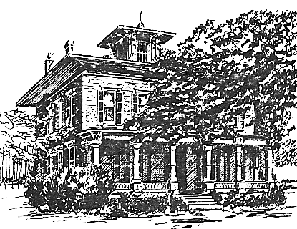
WINTER 2023 NEWSLETTER
Message from the President:
Hello, Everyone!
So many things are being planned right now at the Morgan Manning House that I really feel like shouting- WE'RE BACK! One activity that has already begun is our regular tour schedule. We have been open the first Sunday of the past two months and will continue to put out the welcome sign each first Sunday of the month, from 1:00-3:00pm, through June. Depending on the foot traffic, we will consider more hours. Please come in and see the changes we have made to the displays, especially upstairs.
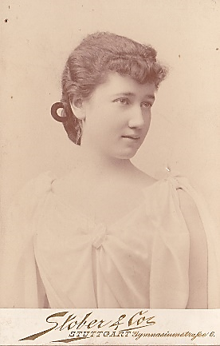 | March 1 is the date of the long-awaited program by Robb Westbrook as he tells us about Sara Morgan's time as a student in Germany. Come and find out why a German beer tasting replaces the usual refreshments that follow. We hope to have the program
available virtually for those who cannot attend in person, although no beer can be provided via internet. Check out website for more info. Robb mentions Daisy Miller in the promotional materials, and I realized that I had never read this or any other Henry James novels. It is not a long book, and surprisingly easy to read for 19th century literature. Spoiler alert: They don't live happily-ever-after.
April brings back the English Tea that was so popular in the past. The committee has been discussing recipes and making plans for an elegant repast. Could there be a nicer place to sip tea and nibble yummies with friends? See details elsewhere in these pages.
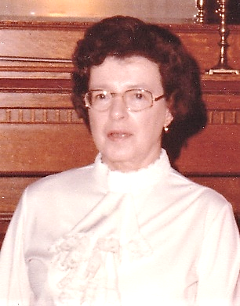 | On a sad note, we continue to lose old friends. Jean Warner served as co-president of the Western Monroe Historical Society from 1980 to 1982 and remained active until she moved away to live with her son Mark and his family. Many remember her from her
years as children's librarian at the "old" Seymour Library. That is where my story with her started. In fact, she was Acting Director when she hired me as a page, my first job. It was a wonderful experience for a high school student. Jean was always impeccably dressed and absolutely fit the definition of "lady". She was a terrific cook and active in the community. Condolences to her family.
Best wishes to all. I hope that you find a reason to visit us soon!
Mary Lynne Turner, President
Upcoming Program & Event:
🏵 Wednesday, March 1, at 7pm: What sort of girl was Sara Morgan when she travelled abroad in the early 1890s? An independent, innocent, sportive American girl of the Gilded Age? One who contravened genteel convention? Perhaps even a flirt? Professor of History Emeritus Robert B. Westbrook explores the clash of American and European sensibilities in the late 1800s in a wonderful presentation juxtaposing Sara with the protagonist Daisy Miller from Henry James’s 1878 novella of the same name.
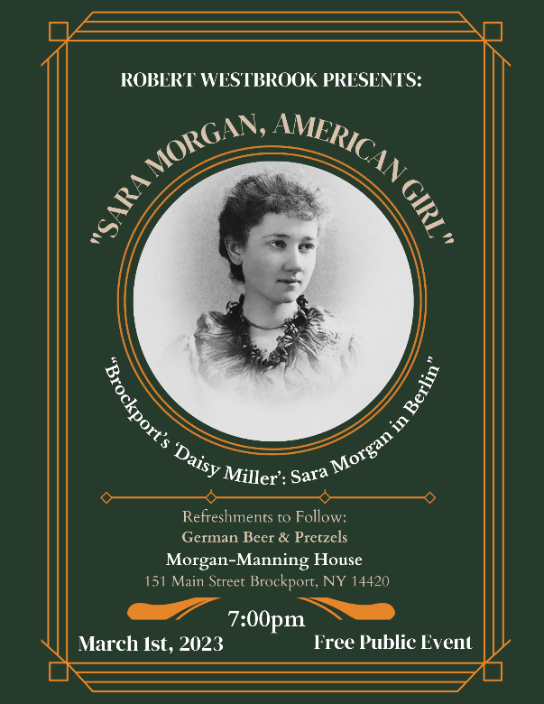
The program is free and open to the public. The WMHS invites everyone to stay for refreshments – German beer & pretzels in honor of Sara – after the presentation.
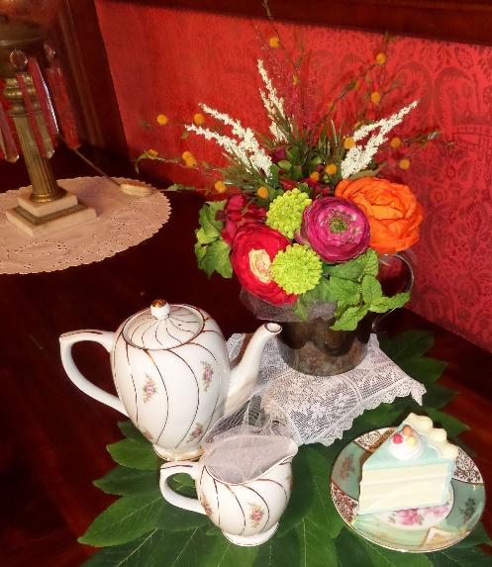
🏵 Sunday, April 16 – English Tea: Enjoy savory and sweet treats in style! $30 per member, $35 per guest. Reservations will open up on March 13. Call Stephanie at 637-3645 or e-mail (morganmanninghouse@gmail.com) after that date to be sure that you can join us that day. Seating is limited!
Curator’s Corner – “Time flies.” A cliché expression we often hear and say, probably because it generally feels so true. And it is indeed how I feel today as I reflect on the five years that I have spent at the Morgan-Manning House! It sometimes seems that I arrived in Brockport yesterday (even though it was in the summer of 2017) but, mostly, it is clear that Brockport and its community are where my husband BoB and I belong.
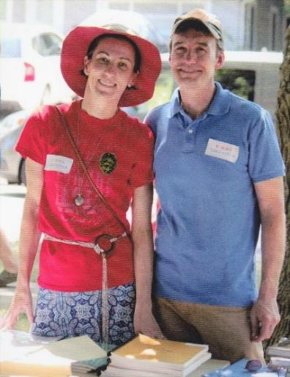
With BoB at our first 4th of July celebration at the House in 2018.
Work anniversaries are always a good opportunity to review what has been done and consider what still needs to be accomplished. In January 2018, I started at the Western Monroe Historical Society as Historian, following in the footsteps of Eunice Chestnut, who has left a deep mark in the Society and in the Village. I first focused on the archival material that Eunice had gathered during the almost forty years of her tenure. Just as our vision of the Society changed—our mission is now focused on the story and the legacy of the Morgan family—my position has also evolved and I am now the curator of the Morgan-Manning House, our main asset as we wish to share with the community the lives and times of the Morgan family during the Victorian era. You have heard us say times and times again that our old home constantly needs some TLC. That is undoubtedly true and we will continue to strive to maintain it in the best of shape, while maintaining its historical integrity.
These past three years, to help me in my duties of stewardship, I have been most fortunate to benefit from the help of numerous interns from SUNY Brockport, who choose to pursue their Museum Studies minor by interning at the Morgan-Manning House. This strong partnership with SUNY Brockport’s departments of History and Anthropology has seen us through the challenging years of the pandemic: we never closed and were able to safely offer internship opportunities.
Nancy Sanger shows Anastasia Figueroa how to do needle felting.
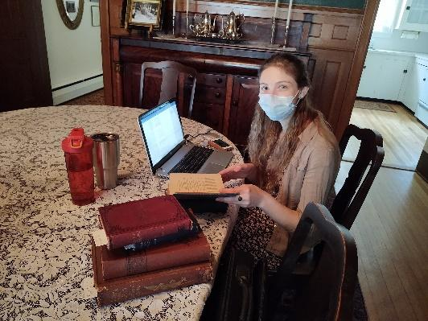
In July 2020, Sydney Salisburg had all the dining room to herself to do her work in a safe environment.

It is heartwarming to see all that has been accomplished these past few years – our newsletters are testimony to this work – but we still have much to do! Our artifact collection needs to be fully recorded; the papers of the Morgan family need to be digitized and transcribed; and more educational programs need to be created to share the Morgan’s stories. More interns are currently working with me this semester and will share with you all they are doing to help me reach my goals. Stay tuned for their stories in the next newsletters!

To close this month’s message, I would like to highlight how perfect a location the Morgan-Manning House is for a Town & Gown gathering. The Spinners Group of Brockport: comprised of spinners, weavers, lace-makers, felt artists, and fiber artists, hosted the students of the History of Fashion class in a hand-on workshop at the Morgan-Manning House on February 10th.
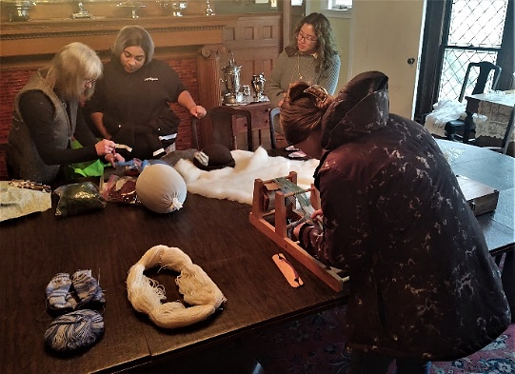

Gail Argetsinger (Department Theatre and Music Studies, SUNY Brockport), the instructor of the course which studies apparel throughout history, wanted the class to understand how labor-intensive every square inch of cloth was before the days of power looms and spinners. Since the Morgan-Manning House is also the meeting place of the Spinners Group, we brought the two groups together so that the artisans could teach the students ancient cloth-making practices, including spinning wool on a variety of spinning wheel devices. This included drop spindles , which were used before the invention of the spinning wheel in the fourteenth century. The fiber artists also demonstrated bobbin lace making, weaving on a variety of looms, and felt-making from alpaca wool.
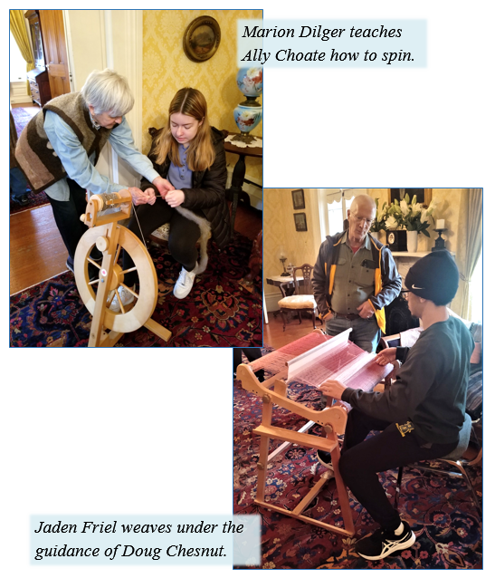
Gail and I wish to thank Nancy Bagoly, Cathy & Doug Chesnut, Marion Dilger, Nancy Sanger, and Linda Tague for sharing their knowledge and their tools with all of us. The students have not stopped talking about it since their visit!
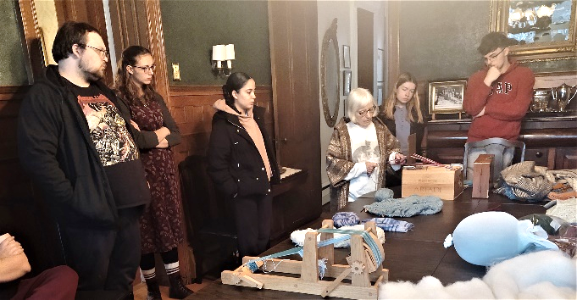
Linda Tague shows us how to use a tape loom
Rozenn Bailleul-LeSuer, Curator
Thank you to:
- Mike &Linda Schaffer for their donation in honor of Gordy & Peggy Fox’s 55th Wedding Anniversary
- Patricia Coates for her donation in honor of her 31st Anniversary
- The Terry Family Talent Foundation for their generous donation
- Pat Kutz and Jacqueline Davis for donations toward the Museum Room
- John & Susan Bixler, John & Linda Bowser, Susan Campbell, Annette & David Crane-Newman, Gordy & Peggy Fox, Mary Halpin, Mary Hazen, Haney & William Heyen, Sharon Kehoe, Pamela & Gregory Ketchum, Brian & Patricia Lemon, Gerald & Sandra Maar, James & Cathy Martin, Chris Mazzarella, Mary & Terry Rich, Rosa Rich, Jocelyn Rowley, Victoria Salomone, , Carolyn Skill, Leslie & Joanne Tandler, Sharon & Scott Valet, Julie Wilson

Our Heartfelt Sympathy goes to Charlie Garlock, descendant of the Morgan family and strong supporter of the Society, for the passing of his wife Elizabeth on January 14. We wish him peace, comfort, and courage at this difficult time.

MARCH & APRIL 2023 CALENDAR
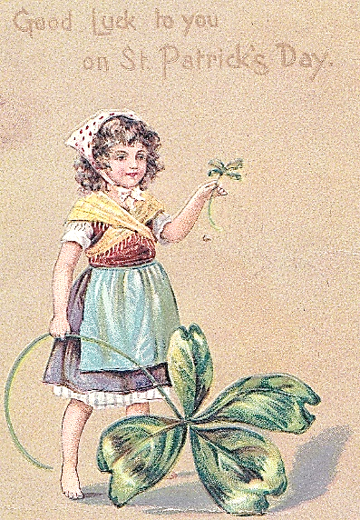 | March 1 Wednesday – 7 pm – Program: Sara Morgan, American Girl, presented by Robb Westbrook  March 5 Sunday 1-3 pm House open for tours  March 14 Tuesday – 7 pm – Board Meeting  March 17 & 31 – Fridays 1-5 pm House closed for private function  April 2 Sunday 1-3 pm House open for tours  April 11 Tuesday – 7 pm – Board Meeting  April 16 Sunday 2-4 pm English Tea | 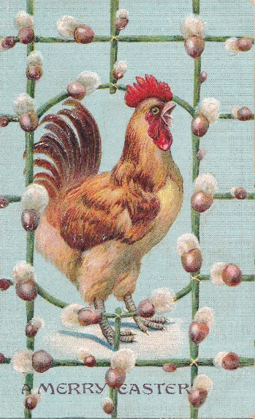

MISSION STATEMENT:
The Western Monroe Historical Society is committed to educating diverse audiences on the life and times of the Morgan-Manning house; preserving this Brockport landmark as a historical museum; providing a repository for a collection of archival materials and artifacts related to the Morgan family; and extending its legacy.

Western Monroe Historical Society - Morgan Manning House
151 Main Street, Brockport, NY 14420-1909 Office Hours Monday-Friday 9:30 am to 1:30 pm 585-637-3645
www.morganmanninghouse.org E-mail: morganmanninghouse@gmail.com
www.facebook.com/pages/Western-Monroe-Historical-Society
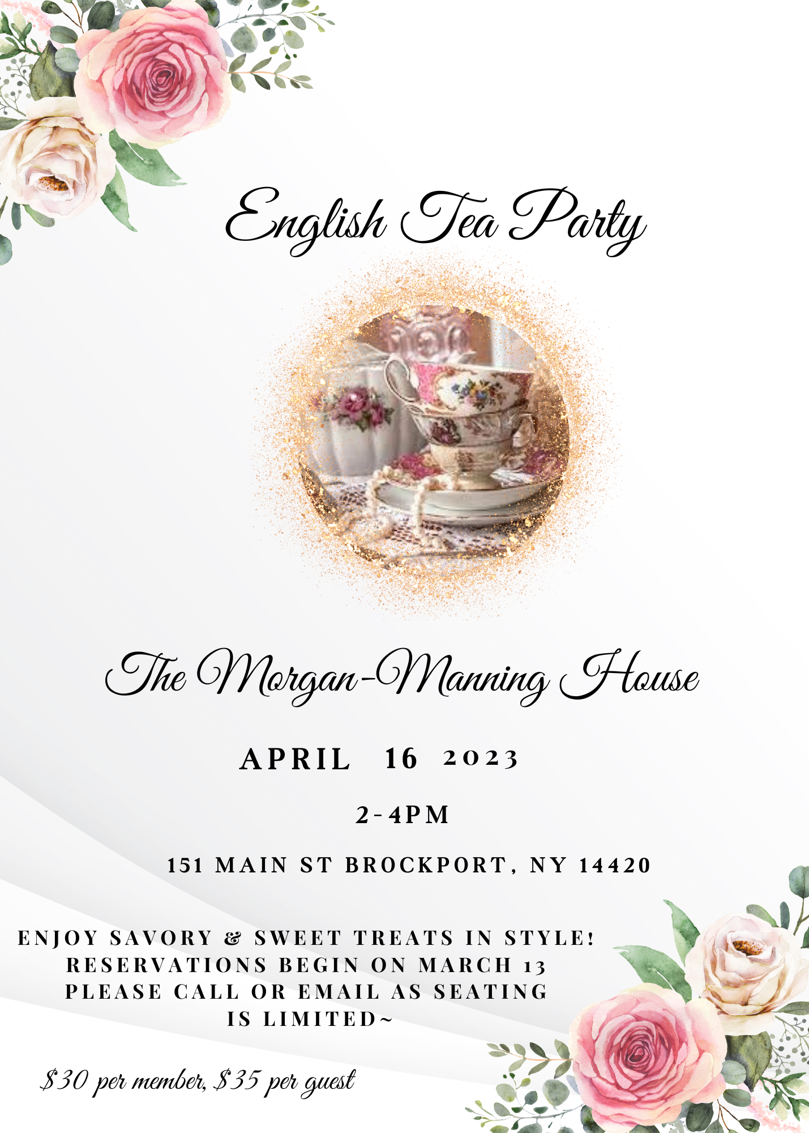

Western Monroe Historical Society
NON-PROFIT ORGANIZATION
U.S. POSTAGE
P A I D
BROCKPORT, N.Y.
Permit No. 32
Morgan-Manning House
151 Main Street
Brockport, NY 14420-1909

--------

These fine businesses in the Brockport area are supporters of the Western Monroe Historical Society. We encourage you to patronize them.

Arjuna Florist and Design Shoppe
Bittersweet
Brad's Northside Service
Brockport Animal Hospital
Brockport Auxiliary
Brockport Custom Carpet
Brockport Optometry - Dr. Raff
Carriage Place & Antique Co-op
Coleen’s Kitchen
Dunn's Furnishings, Inc.
58 Main BBQ & Brew
Five Star Bank
Fowler Funeral Home, Inc.
Hart Gallery 27
Hurd Orchards
Kirby's Farm Market
Klafehn Heise & Johnson, PLLC
Lift Bridge Book Shop
Mahan Discount Liquor & Wine, Inc.
RE/MAX Titanium, LLC
Robb Farms
Salmon Creek Nursery
Sara's Garden Center
Strong West – Brockport
The Victorian Bed & Breakfast
The White Farm Bed & Breakfast
Thomas E. Burger Funeral Home
Trader Shag’s Emporium
Maxwell Thaney, DDS - Brockport Smiles
Westside News Inc.

