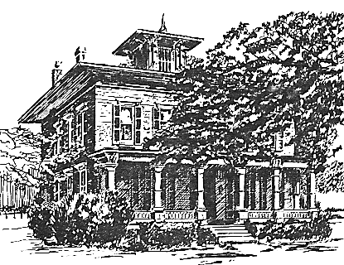
July 2020 NEWSLETTER
Greetings from the President
Dear Members,
Summer has brought us opportunities to proceed cautiously with projects. The first has been in the dream stage for several years. We have the 1897 plan designed by Landscape Architect from Rochester, W. W. Parce. The ideal would be to replicate it exactly, but a number of factors make that impossible. Obstacles include the presence of some very large trees that were not in the original drawings and the unavailability of some of the plants. Some decisions have been made, however, to bring in certain trees and bushes that will help create the feel of the gardens. Cindy Graves has been working hard on some of the shrubbery already.
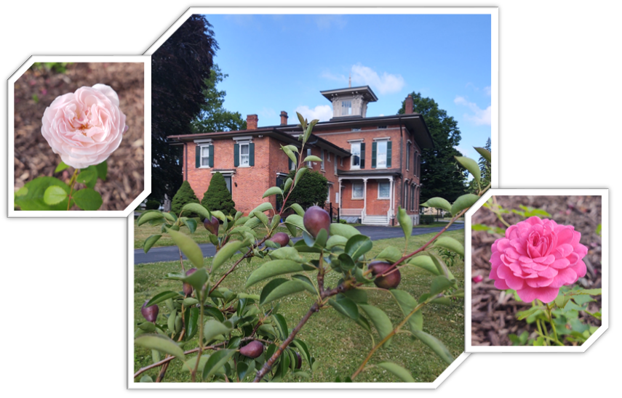
We are so looking forward to having our assessors examine our buildings, collections and archives in August. Their suggestions will let us prioritize upgrades and make sure that our procedures and plans are sound. Our ad hoc Museum Room Committee will be able to go forward, finalize designs, write narratives, and set dates to complete the project. Rozenn, in her new role as Curator, will be working on the structure needed to reach these objectives.
We do have a number of opportunities for volunteers coming up. Please let us know if you are willing to work on projects inside or outside. Membership materials are going out later than usual, but you should receive them by the end of this month.
Thank you so much to those who have congratulated me on my presidency. I find it amusing, as I did not really have any opposition, but the support is appreciated. There is so much to learn despite my decades with the House. That reminds me that I really have no plans for the 4th of July. I have spent 30+ years celebrating with many of you right here on the grounds. Listening to bands, eating sausages and enjoying the cake walk are traditions that have been interrupted. Let's hope that they return as part of the “new normal” next year.
We are anticipating that we will be able to hold Peddler's Market in September, possibly with modifications. That decision will be made at a later date. It looks doubtful that Candlelight Christmas 2020 will happen, as it requires a great deal of planning that we, and our vendors, just cannot do with any certainty at this time. We will keep you informed.
Stay safe!
Mary Lynne
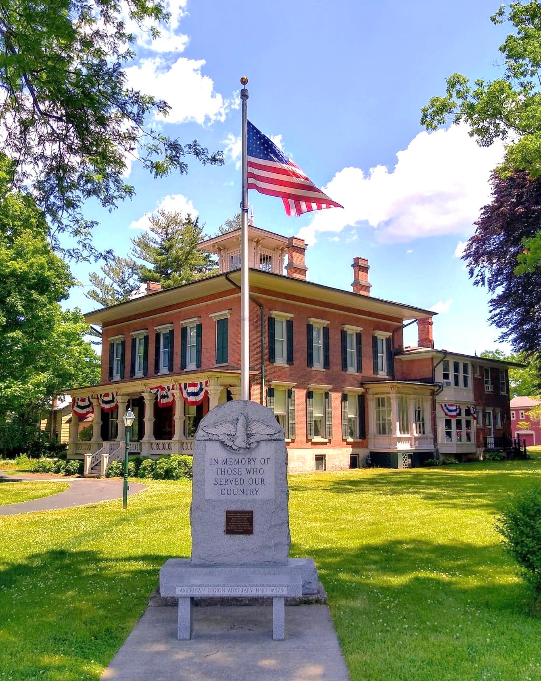
©Kellie Whalen
History Corner:
If you have had a chance to read Eunice Chesnut’s book, And Papa Cried Hoorah, and if you have visited the Morgan-Manning House, you may remember the name Eloise Morgan. She was the wife of George, Dayton and Susan Morgan’s oldest son. At the time they married in 1895, she was a renowned opera singer in Boston and she later appeared on the Broadway stage. Eloise also had artistic talents, as shown by the portrait she painted of her husband, now on display in the Red Room. George and Eloise eventually settled in Miami Beach, Florida. Until two weeks ago, this was all the information I had gathered on Eloise. So many new details have since surfaced thanks to the investigative skills of Mary Lynne Turner and her brother, Gary Welch. While looking for a map of Brockport, Gary stumbled on a photograph of a certain Ollie Archmere, “later known as D. Eloise Morgan” (see image below).
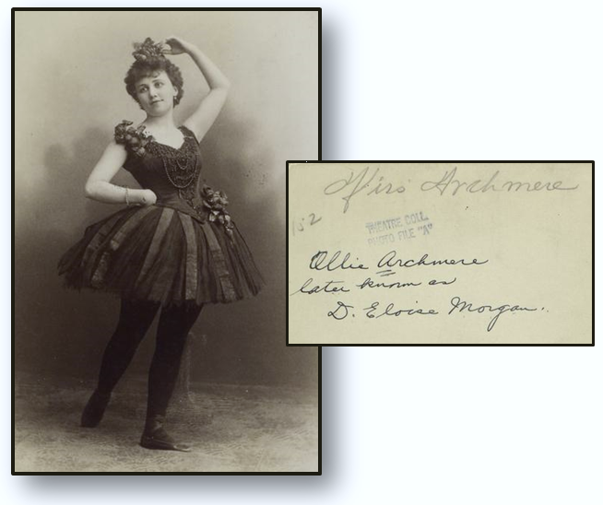
Could this person be “our” Eloise? It turns out that it was! Here is a brief presentation of what Gary and Mary Lynne discovered about Eloise’s life and career on the stage before she became Mrs. George D. Morgan.
Della Eloise Berry was born on June 26, 1867, in Red Bluff, CA, to Lucy Eunice Smith, age 23, and John Walker Berry, age 24. At the age of 15, some evidence suggests that she may have married Willard Rude Wright, age 24, on June 2, 1883. A year later, on September 11, 1884, their daughter, Della Derby Wright, was born in Sacramento, CA. Willard and Della Eloise did not remain married very long and may have been divorced by 1888. Finding additional information on Della Derby Wright, however, has been most challenging. Gary discovered the death certificate, dated 1946, of a daughter born circa 1885to Willard Wright and Eloise Morgan. This lady, a widowed writer living in Hollywood, CA, was named Loren Stevens. Did Della Derby Wright change her name? Very intriguing to say the least! More research on this conundrum remains to be done.
In the meantime, in 1886, Della Eloise Berry began her professional career, acting and singing in musical comedies and vaudevilles. Under the name of Ollie Archmere, she paired with Lulu Morrill-Dupree and the two artists became known as the Archmere sisters. The Kansas City Press (14 Sept. 1894) described the early years of Eloise on the stage as follows: “She entered the field of farce comedy, under the name of Ollie Archmere, and acquitted herself most creditably in the companies of Evans & Hoey, John Russel and Hoyt & Thomas. She also sang with opera companies two summers, thereby gaining valuable experience and becoming familiar with a large number of operas.” It was also reported that, in the New York play Clipper, “Ollie Archmere, the bright Californian, who has been a pronounced vocal business for the past few seasons in the East, was the local leader of the ladies, and her encores were fully deserved” (Record-Union, Sacramento, 2 Mar. 1890)
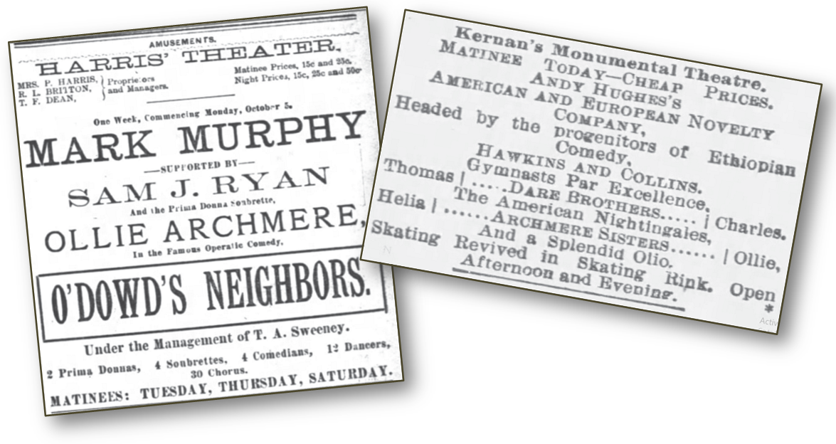
We further learn more about her characteristics as a singer and a performer in Volume 6 of the Gallery of Players, a publication filled with the biographical sketches of the stage artists of the time:
“Miss Morgan’s voice is a light soprano; it is very flexible and of wide range, and she possesses a high note—G in alt—that is phenomenal. Moreover she is young, graceful and pretty—all commendable qualities in heroines of an opera comique, but, alas!, too rarely possessed by them” (Gallery of Players 6 (1895), p. 36).
In December 1891, Eloise made the headlines of several newspapers in the country. Ollie Archmere was then performing as Flirt in A Trip to Chinatown, at the Madison-Square Theater in New York City. The San Francisco Call reports that “The ‘Flirt’ has flown. Miss Archmere creates a sensation in New York Theatrical Circles” (Dec. 26, 1891). In The Bostonian, we learn that “Miss Ollie Archmere is now making a trip to Europe, having taken a French leave (i.e., an unauthorized or unannounced departure) from A Trip to Chinatown this week” (Dec. 20, 1890).
What made Eloise leave the country so abruptly? This is when George Morgan comes in! Some months later, Eloise publicly explained that “she had suddenly embraced the opportunity afforded her by a friend (i.e., George) to study music abroad.” We have yet to discover how the two met, but it is quite possible that George saw her perform and fell under her spell. In an article published at the occasion of their marriage in June 1895, George is described as “the man whose devotion to her led him so far that he sent her to Europe two or three years ago for the purpose of permitting her to complete her education in music. […] He was deeply in love with the pretty young actress and urged her to marry him. Miss Archmere declined the honor till she should complete her musical education and perfect herself in her art” (San Francisco Call, 19 June 1895). She spent a few months in Paris learning under Madame La Grange, known as an excellent trainer of the voice. “When she resumed the stage, she attested her gratitude by adopting George’s name and appearing under the name of D. Eloise Morgan.” (San Francisco Call, 19 June 1895). As poetically stated in the Akron Daily Democrat (15 Sept. 1894), “she emerged from the Archmere farce chrysalis as the D. Eloise Morgan opera butterfly.” During the 1893-94 season, she appeared on the New York stage as Baucis, in Gounod’s Philemon and Baucis, and as Yum Yum, in the Gilbert and Sullivan’s opera, The Mikado.
Eloise as Yum Yum in The Mikado
Reaching her ultimate goal, she was offered a position of Prima Donna in Boston. Only then did she agree to become Mrs. Morgan at the end of the 1894-95 season, as written in the Boston Globe (9 June 1895). The wedding took place shortly after sunrise, on June 18, 1895, in the residence of Eloise’s mother, Mrs. Berry, in Cleveland, OH. It is said that “Mrs. Morgan was charmingly attired in white silk with an overdress of white embroidered chiffon. She wore a veil and orange blossoms in spite of the earliness of the hour.”
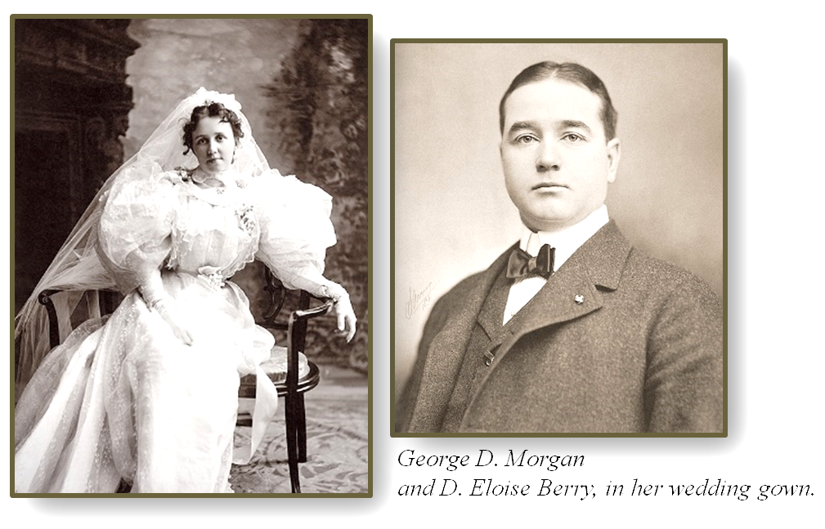
While I will now pursue my investigation into the operatic career of Eloise Morgan, I cannot thank Gary and Mary Lynne enough for their online investigation. Who would have known there was a national celebrity, with her share of gossips and scandals, as a member of the Morgan family?
Rozenn Bailleul-LeSuer, Curator/Historian
Hasn’t 2020 been a noteworthy year so far? We started the year with a rampant pandemic sweeping the world, endured an outburst of murder hornets, and now are responding to the prejudice that has haunted this country for decades, even centuries. The world is definitely going through changes. Yet, this is not the first time American citizens questioned systems of authority. Looking back on the Progressive Era from the 1890s to the 1920s is not all that different from our current experience. The “robber barons” (corporate bosses) leading industry perpetuated the exploitation of labor and monopolized their businesses to eradicate competition. Women peacefully protested and carried out the suffrage movement for nearly a century before the Nineteenth Amendment granted voting rights (August 18, 1920). American citizens understood that it was a necessity to enact protection for workers, consumers, and the environment.
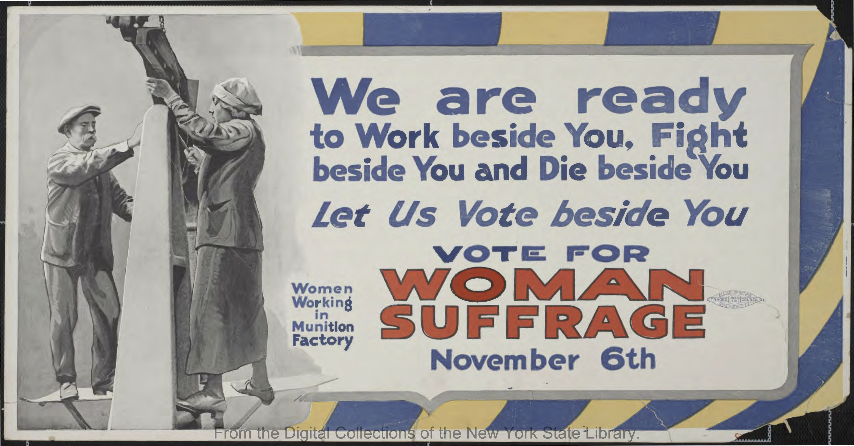
Though there was much positive change during the Progressive Era, prejudice remained pervasive. There was a revival of the Ku Klux Klan in the last decade of the Progressive era, extending the oppression and fear of the African American community. Xenophobic rhetoric blamed immigrants for the poor economy and working conditions, leading to a harsh exclusionary policy against almost anyone of Asian descent (Immigration Act of 1917). Within the Progressive Era of reform, the influenza pandemic affected about 500 million, with estimated 50 million deaths worldwide, lasting from February 1918 to April 1920.
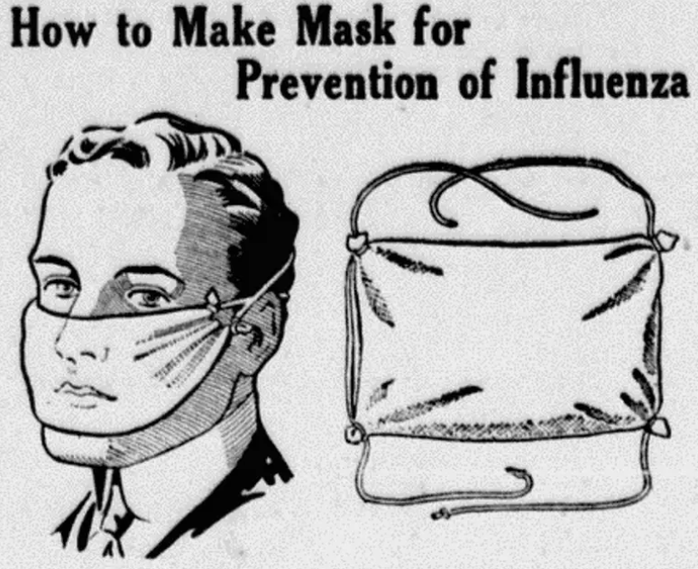
© Edmonton Bulletin, 1918
Now here we are today, a century later, still cautious of the coronavirus pandemic putting us at risk, though unable to succumb to the inequality still present in our society. People from all backgrounds are coming together in hopes of creating a more colorful and accepting world.
The Morgan family that once occupied the Morgan-Manning House lived through the reforms of the Progressive Era, though we are not sure what their stance was. This is a great time to reevaluate your stance in the world and use your voice!
Sydney Salisburg, Anthropology intern at the MMH
This Summer at the MMH:
We have received so many donations this month that we cannot wait until September and Peddlers Market to start selling items off! Join us on Saturday, July 18 from 10am-2pm for our SOCIALLY DISTANCED LAWN SALE. We will have books, baskets, bicycles, toys, kitchenware, rugs, wall art, lawn furniture, garden tools, and so much more displayed around the property. Masks will be required. The House will not be open, and we will not be selling food. If you or your teenager would be willing to volunteer with set up, tear down, or help during the event, please call 637-3645 and leave a message by noon on Wednesday, July 15. Thank you and we look forward to having you shop some of the treasures that we have received.
We will start having tours during the summer. They will be by appointment only. Guests will be asked to wear masks, and tours will be limited to 6 people at a time. Thank you for your understanding.
Thank you to:
- Bruce Leslie for his donation in memory of Helen Maier.
- Cathy and Doug Chesnut for making several masks for our guests and volunteers at the Morgan-Manning house.
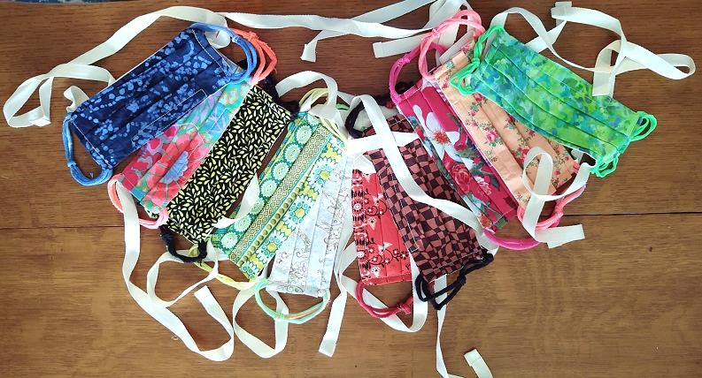
Just like in 1918, masks are one of the precautions we can use to prevent the spread of COVID-19. We value the health and safety of our community and therefore ask our visitors to wear masks at the House. Thank you for your cooperation!
A look back to give us hope for the future: 4th of July memories at the Morgan-Manning House (2011-2019)
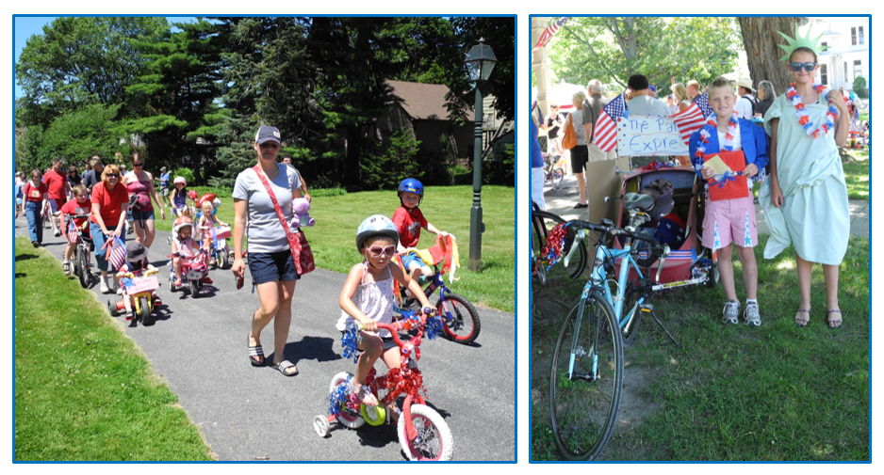

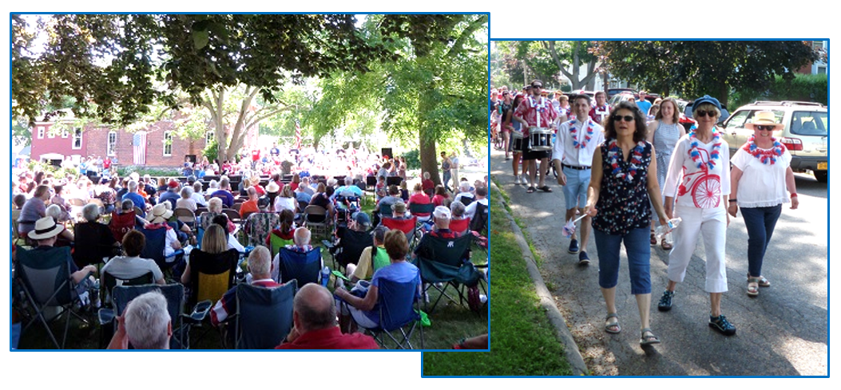

Our Flag, by Eloise Morgan
The stars and the stripes how bravely they wave,
O’er land, o’er sea and o’er thee, my lad;
The stripes are the staff, the stars are the notes,
And a merry, merry tune they make as they float.
The tune is of freedom, of worth and of growth.
O’er mountains so high and our broad spreading streams,
Where wild flowers wave and wide rivelets run,
In this glorious land where freedom was won.
Our freedom we won from a crown o’er the sea,
A crown so bold and brave;
It partook of our profits, but scoffed at the aims
Of the beauteous country where freedom was gained.
Oh, where is the land of our peace and plenty,
the working man’s home is our pride;
Our arms are outstretched to the poor and oppressed
The bounteous land where wrongs are redressed.
So hang out your flag this glorious fourth,
The stripes are one with the breeze – and the stars
Shine on the azure one with the sky,
God bless our nation – our peace sanctify.

Brockport Republic and Democrat, July 3, 1952:

JULY CALENDAR

July 18 – Sat – 10am-2pm – Lawn Sale

MISSION STATEMENT:

The Western Monroe Historical Society is committed to educating the community and future generations on the history of the Morgan-Manning House, celebrating our heritage, and preserving this local landmark that is listed on the National Register of Historic Places.

Western Monroe Historical Society - Morgan Manning House
151 Main Street, Brockport, NY 14420-1909
Office Hours Monday-Friday 9:30 am to 1:30 pm 585-637-3645
www.morganmanninghouse.org E-mail: morganmanninghouse@gmail.com

Western Monroe Historical Society
NON-PROFIT ORGANIZATION
U.S. POSTAGE
P A I D
BROCKPORT, N.Y.
Permit No. 32
Morgan-Manning House
151 Main Street
Brockport, NY 14420-1909

--------

These fine businesses in the Brockport area are supporters of the Western Monroe Historical Society. We encourage you to patronize them.

Arjuna Florist and Design Shoppe
Bateman Orthodontics - Dr. Bateman
Bittersweet
Brad's Northside Service
Brockport Animal Hospital
Brockport Auxiliary
Brockport Custom Carpet
Brockport Optometry - Dr. Raff
Carriage Place & Antique Co-op
Country Treasures
Dunn's Furnishings, Inc.
58 Main BBQ & Brew
Five Star Bank
Fowler Funeral Home, Inc.
Hurd Orchards
Kirby's Farm Market

Klafehn Heise & Johnson, PLLC
Lift Bridge Book Shop
Mahan Discount Liquor & Wine, Inc.
Oakes Tree Service
RE/MAX Titanium, LLC
Robb Farms
Salmon Creek Nursery
Sara's Garden Center
Seaward Candies
Strong West – Brockport
The Victorian Bed & Breakfast
The White Farm Bed & Breakfast
Thomas E. Burger Funeral Home
Maxwell Thaney, DDS - Brockport Smiles
Westside News Inc.

